Group ID: A1

Group Members:

LAM Man Ho (1155159171)

MA Yu Ying (1155157879)

CHEUNG Ka Ho (1155158622)

FUNG Ngai Man (1155158312)

LI, Eric John (1155159116)

Department of Computer Science and Engineering (The Chinese University of Hong Kong)

Date: 24/02/2023

DFD Specification Document

Table of Contents

1. High-Level Context Diagram 2

2. Feature Diagram 2

2.1 Account Management System 2

2.2 User Operations 3

**2.2.1 Password System** 3

**2.2.2 User Profile System** 4

**2.2.3 User Following System** 4

2.3 Buzzes Features 5

**2.3.1 Posting System** 5

**2.3.2 Comment System** 6

**2.3.3 Like & Dislike System** 6

**2.3.4 Mention System** 6

2.4 Searching System 7

2.5 Recommendation System 7

2.7 Hive System 8

2.8 Admin Operations 9

**2.8.1 Buzz Controlling System** 9

**2.8.2 User Controlling System** 9

# **1.** **High-Level Context Diagram**

Figure 1 High-Level Context Diagram

# 

# **2. Feature Diagram**

## **2.1 Account Management System**

Account System includes **Login**, **Logout** and **Registration** features.

**Login** feature allows users login to their personal account (has higher permissions) through either email or user id with the password. The browser keeps the login status unless it is closed or logout.

**Logout** feature allows users logout of their current account.

**Registration** feature allows users to register their own accounts through email.

Figure 2 Account Management System DFD

## 

## **2.2** **User Operations**

User Operations include **Password System**, **User Profile System** and **User Following System**. Here shows the overall DFD for User Operations.

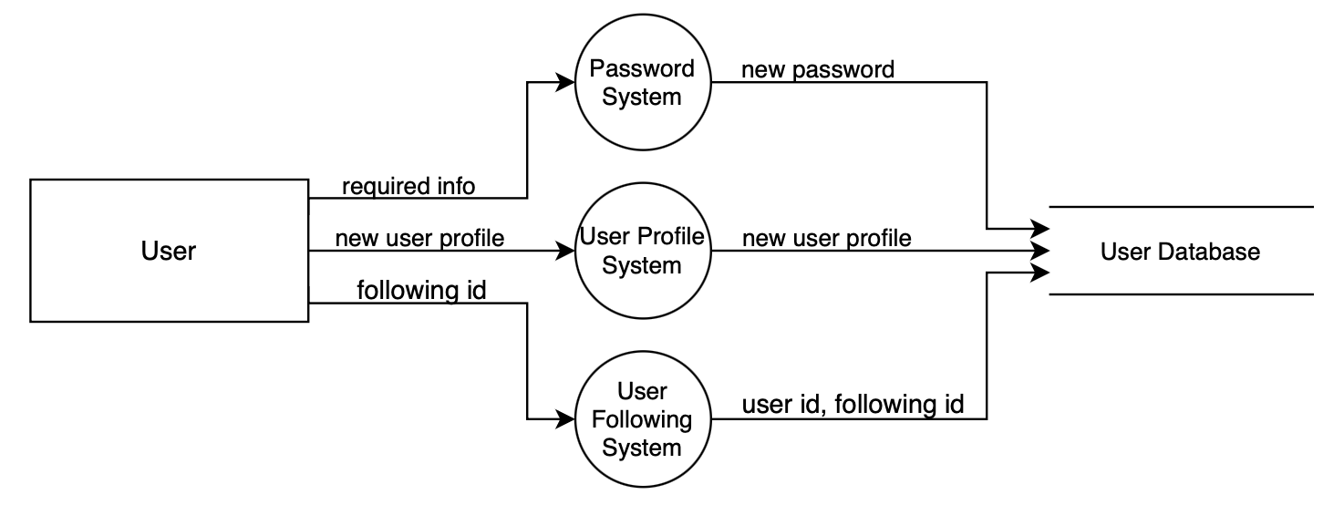

Figure 3 Overall DFD of User Operations

### **2.2.1** **Password System**

**Password System** allows users to reset their password through either “Forgot password” or “Change password”. "Forgot password" requires user's email and a specific verification code. "Change password" requires user's old password.

Figure 4 Password System DFD

### **2.2.2** **User Profile System**

**User Profile System** allows users to edit their profile, including username, description, user icon and favorite categories.

Figure 5 User Profile System DFD

### **2.2.3 User Following System**

**User Following system** allows users to follow the Buzzer users that they are interested in.

**Users that want to follow others** can simply click the following button, and their following list will be updated to include the users they want to follow. **Users being followed** would simply be notified, and have their follower list updated.

Figure 6 User Following System DFD

## **2.3** **Buzzes Features**

Buzzes Features include **Posting System**, **Comment System**, **Like & Dislike System** and **Mention System**. Here shows the overall DFD for Buzzes Features.

Figure 7 Overall DFD of Buzzes Features

### **2.3.1 Posting System**

The Posting System includes the “Post a buzz” and “Re-buzz” functions.

“Post a buzz” allows the current user to post a buzz by entering the topic of the post, the text the user want to include, attach either the image or video the user wants to share.

“Re-buzz” allows the current user to share other users’ buzzes, which would also be regarded as their own buzzes.

Figure 8 Buzz Posting System DFD

### **2.3.2 Comment System**

The **Comment System** allows the users to comment on the original Buzz, and to reply to other users in the comment section. Users are allowed to input text messages in the comment section.

Figure 9 Comment System DFD

### **2.3.3 Like & Dislike System**

The **Like & Dislike System** is responsible for the likes of each buzz. When the like/dislike button is triggered by the user, the number of likes display on screen would be updated in real time correspondingly.

Figure 10 Like & Dislike System DFD

### **2.3.4 Mention System**

The **Mention System** allows the users to mention other users. Users using Buzzer can mention other users in their Buzzes/comments by inputting either @<username> or @<user id>. Users being mentioned would also receive notification from Buzzer to direct them to the corresponding Buzzes/comments that mentioned them.

Note that not only @ is considered as mentioning, but following others, re-buzzing others’ buzzes and replying to others in the buzz comment section is also regarded as mentioning, so will be manipulated by the mention system to notify the mentioned users.

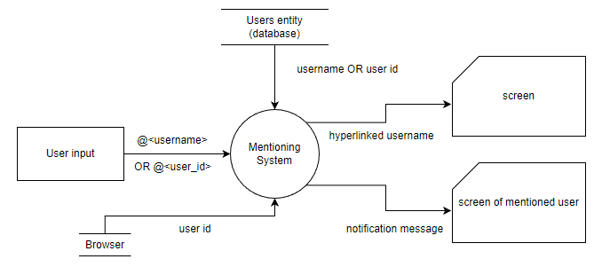

Figure 11 Mention System DFD

## **2.4 Searching System**

**Searching System** can search for the relevant “buzzes” or users based on user's inputs. In addition, the user searching system would dynamically update the users' preview list for each character that the user inputted.

Figure 12 Searching System DFD

## **2.5 Recommendation System**

**Recommendation System** includes the User recommendation system and Buzz recommendation system.

**User recommendation system** recommends a current user a list of Buzzer users that shares the common interest (based on the categories they favoured) with him/her.

**Buzz recommendation system** recommends a current user a list of Buzzes which he/her would be interest (based on the categories of Buzzes), regardless of whether the Buzzes are posted by followed user or not.

Figure 13 Recommendation System DFD

**2.6 Private Chat System**

**Private Chat System** allows users to start a private chat with another user. In the private chat room, the users are allowed to interact with each other by sending text, images, and videos.

Figure 15 Private Chat System DFD

## **2.7 Hive System**

**Hive System** is responsible for manipulating the “Hive” feature provided by the Buzzer application. Users are allowed to build their own “Hive” like a bee. The Hives are being built by hexagonal cells which are responsible by the system. Users will gain daily check-in experience as an award to encourage users to share their daily life. The experience will be converted into user active level which is next to the username. All the mentioned feature, also the inputted text and message are being managed by the system.

Figure 16 Hive System DFD

## **2.8 Admin Operations**

### **2.8.1** **Buzz Controlling System**

**Post Deletion System** allows the administrators to delete the buzzes posted by the users which violates the community regulation from the system. The deleted buzzes would be removed permanently from the database. In addition, whenever a user’s buzz is deleted, an email would be automatically sent to the user.

Figure 17 Buzz Controlling System DFD

### **2.8.2 User Controlling System**

**The User Controlling System** includes **the User Deletion System and User Verification System.** In general, the **User Controlling System** allows the administrators to manage users through viewing through a list of users. Moreover, the system allows the administrators to delete a user, or verify a user in the user list display page.

**User Deletion System** allows the administrators to delete a Buzzer user from the system if the administrators agree that the user is violating the community regulation. The deleted user would be permanently removed from the User database. In addition, whenever a user is deleted, an email would be automatically sent to the user.

**User Verification System** allows the administrators to verify a Buzzer user from the system. Users being verified would have a blue checkmark displayed next to their username in all pages displaying their names.

Figure 18 User Controlling System DFD